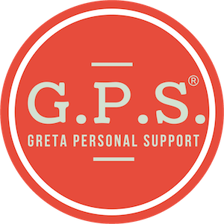
…for those who have to manage your own
website, social media, SEO, Google analytics,
marketing & strategy…

Help is here.
Dear ,

If you’re like me, I’ve worked hard to create a business I’m proud of but struggle to keep up with technology and digital marketing. I secretly hate it! #CEOconfession

Today you’re expected to be an expert at all this crap. And, you’re doing your best to figure it all out. But you’re also driving yourself insane – wasting hours of time on things that should’ve been “easy,” struggling through technical conversations with hosting companies that speak an alien language, making you feel embarrassed and stupid for needing help (“I have a college degree and I can’t update a stupid link? What’s wrong with me?”)… and don’t even get me started on SEO or website updates. #overwhelmed

Have you ever said, “If only someone could just tell me exactly what to do…”?

G.P.S. is exactly that! #somebodypinchme

G.P.S. is a simple monthly subscription service where you can ask Greta Rose (award-winning digital expert and author, highly respected in her industry) a really specific question about a wide range of subjects, and she will send you a super specific, easy-to-follow set of instructions, along with a video tutorial. You can watch the video, follow the instructions, until your question is answered. You can store your conversation in your member area for a rainy day, or share it with your team at work… up to you.

Your business is unique, and so are your questions.

G.P.S. makes it possible to have an actual person you know and trust in your pocket to help you, anytime you need it. G.P.S. is the support you want, the information you need, plus a dash of inspiration thrown in just for fun.

If this sounds intriguing to you, I’d like to show you G.P.S. so you can see for yourself how great it is.

Whether you just need a gentle nudge, or someone to hold your hand and spend one-on-one time with you, you can make sure you have just the right amount of G.P.S. in your corner.

Cheers,

Name
Affiliate link

P.S. Not sure how much help you need? Take the G.P.S. quiz!

